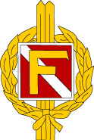 | Resultat  Götalandsmästerskap distriktstävling | 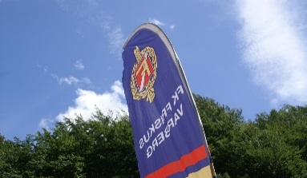

 | Distrikt | Sprint | Lång | Stafett | Totalt
1 | Småland OF | 5:54:19 | 16:46:58 | 5:35:55 | 28:17:12
2 | Göteborg OF | 6:34:52 | 18:17:26 | 6:01:32 | 30:53:50
3 | Västergötland OF | 6:04:10 | 18:47:38 | 6:16:25 | 31:08:13
4 | Skåne OF | 6:29:41 | 19:10:51 | 6:26:49 | 32:07:21
5 | Östergötland OF | 6:47:59 | 21:02:12 | 7:24:01 | 35:14:12
6 | Blekinge OF | 7:23:17 | 22:56:42 | 6:38:56 | 36:58:55
7 | Halland OF | 7:58:23 | 24:38:22 | 8:27:47 | 41:04:32
8 | Bohus-Dal OF | 8:58:59 | 26:22:34 | 7:36:09 | 42:57:42
9 | Gotland OF | 9:12:43 | 28:08:25 | 9:48:16 | 47:09:24

