VBN #3 Lövhult
V50 2019

Meeting – Motionsgård Lövhult, Lövhult 7, 571 92 Nässjö

Course lengths – Long 7.9km
Middle 5.3km
Short 3.2km

Map Scale – Long 1:10000
Middle and Short 1:7500

Start – Mass start,
18:15 Long and Middle
18:17 Short

To Start –A short group jog warm up to the Pre Start area. Jog leaving the 18:00

Controls – Training Kites with Reflex stripe

Punching system – SI. Box hung on control kite.

Gaffeling – “Relay gaffel” for long and middle (heavily gaffeled), “Butterfly loops” for short. Control can be very close together!! They will be on different feature but check you control codes.

Control codes – Code for control is next to the control number (example below).

Map turn over – Long course has a two-sided map. You will be handed a rolled-up map 2min before the start. It is your responsibility to check that you are looking at Part 1 for the first half of the course. This is printed in big bold letters on the top left of your maps (example below).
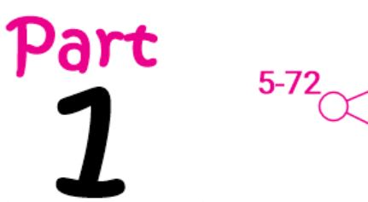

Terrain – Very varied terrain! White is very open and fast running. Green is tough and slow running. Mix of very detailed contours and rocks to vague with very few details.
