VBN #7 - Anneberg South
V4 2020
Middle Distance
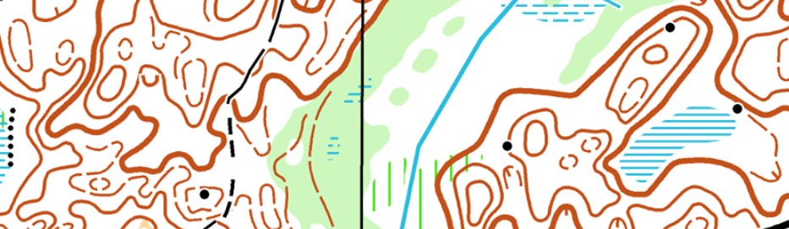
Meeting – 57.696662, 14.836809 - Nässjö N, 571 92 Nässjö

Course lengths – Long and Middle courses are the same. The only difference is that Middle course is for H/D40+. The middle course will have 1:7500 scale map.
Long + Middle 5.6km
Short 2.7km

Map Scale – Long 1:10000. Middle and Short 1:7500
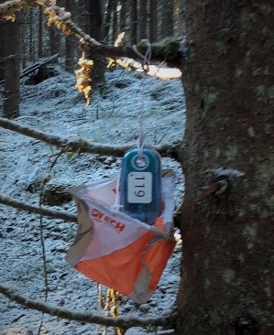
Start – Mass start,
18:15 Long and Middle
18:17 Short
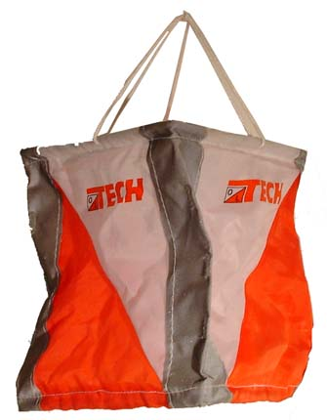
Controls – Training Kites with Reflex stripe

Punching system – SI. Box hung on control kite.

Gaffeling – “Relay gaffel” for all courses. Long and middle are heavily gaffled. Control can be very close together!! VBN#3 I put all gaffels on different control features, but this terrain will not allow this to happen again. Controls can be close together on the same/similar (or look the same) feature!! Check your control codes.

Control codes – Code for control is next to the control number.
Terrain – Physically, mostly very runnable forest with patches of slower/thicker and less visibility. Orienteering, is a lots of contour shapes.

